**Service Description – Convenient and simple sign-up**

## Introduction

In order to not annoy any potential customer, the signing up process has to be as convenient as possible. Not only is it required to sign-up as easy and fast as possible, the whole setting up of his profile should be done “automatically”.

## Customer Segment

Students in their final year before graduation. They are thinking about on where to apply to and are not yet sure now.

## Functions

Sign up with: LinkedIn or aai-logon

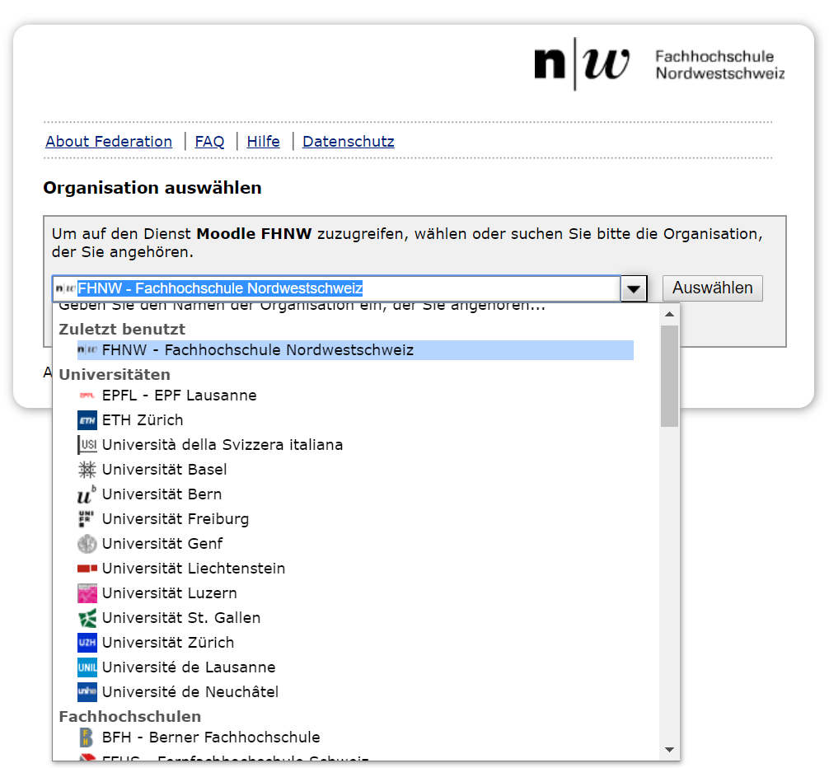

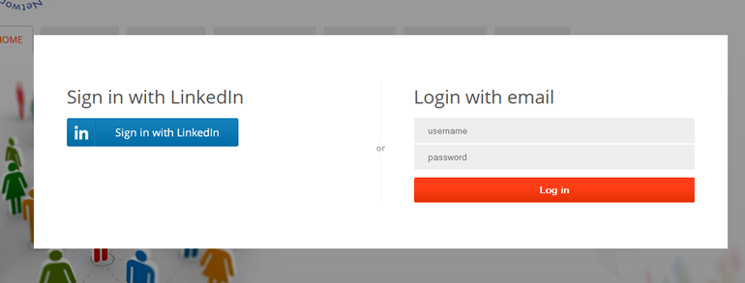

## Revenue Stream / ROI

None

## Value Proposition

The value proposition is on our side. We are able to gain as much data as possible with little to no expense of the other party

## Key Partners

Short-term – FHNW

Long-term – All universities

## Actions required in order to realize the service

Database for the customer data. Connection to aai-logon and LinkedIn.

Important: Security and privacy

Bewertung 1-6

|  |  |  |  |
| --- | --- | --- | --- |
|  | Peter | Yannick | Simon |
| Potential |  |  |  |
| Umsetzbarkeit |  |  |  |
| Priorität |  |  |  |
| MVP Relevanz |  |  |  |

Lean Canvas